Title: Cultures and celebrations
Language: English
CEFR Level: B1/B2/C1
Author: VitBox team

Descriptor:
Mode of communication / Activity, strategy or competence:  speaking, reading, writing, mediation of texts | Scale:  Building on pluricultural repertoire
Descriptor:
B1
Can discuss in simple terms the way in which things that may look “strange” to them in another
sociocultural context may well be “normal” for the other people concerned.
Can discuss in simple terms the way their own culturally determined actions may be perceived differently by people from other cultures.
B2
Can describe and evaluate the viewpoints and practices of their own and other social groups, showing awareness of the implicit values on which judgments and prejudices are frequently based. Can, in an intercultural encounter, recognise that what one normally takes for granted in a particular situation is not necessarily shared by others, and can react and express themselves appropriately.
C1
Can sensitively explain the background to and interpret and discuss aspects of cultural values and practices drawing on intercultural encounters, reading, film, etc.

Introduction to task
Goals of the activity:
generating awareness of otherness. Identifying biased opinions based on prejudices. Interpreting and understanding cultural events and the values associated to them.
Introducing the activity in the classroom:

- ask participants to talk about celebrations that are popular in their countries, regions or towns.
- ask participants to explain where the celebrations come from, what is their origin?
- ask participants to think about what a foreigner might think attending these celebrations with no knowledge of the history behind it

Description of the main activity:
This activity can be carried out in blended learning courses as an online activity or in traditional courses as a classroom activity. As a classroom activity, students need to have access to the internet. Alternatively, they can carry out the research as homework before the activity is carried out in the classroom.

Have the students look at the information about a traditional holiday in Valencia, Spain

Everything you need to know about the Fallas in Valencia, Spain.

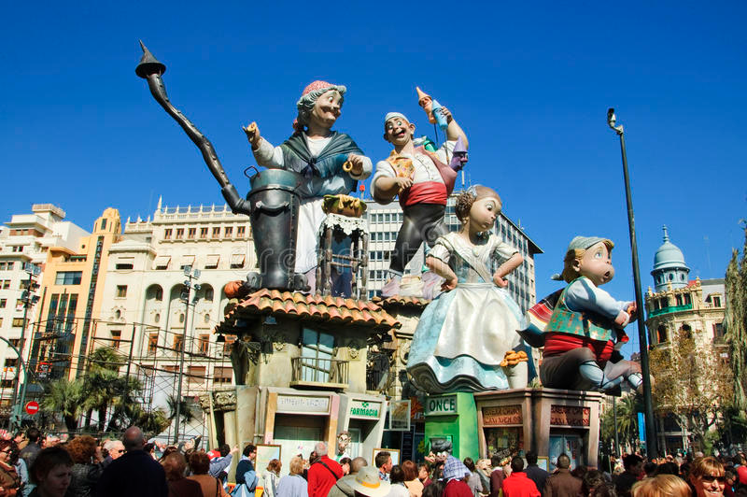

What are the Fallas?
Las Fallas are València's most universal festival, declared Intangible Cultural Heritage of Humanity by UNESCO. Its name refers to the spectacular sculptural monuments made of wood and papier mâché that are placed in the city’s streets and squares to be admired before they succumb to the flames. In addition to the large fallas, there are also children's fallas, much smaller in size, designed by and for the little ones.

What can you see at the Fallas in Valencia?
The main attraction, without a doubt, are the hundreds of fallas, or fallero monuments, which are "planted" in streets and squares all over the city. Each falla usually follows a theme and consists of numerous individual sculptures or sculptural groups, called ninots, which tell their own story. They often depict famous people or critique current affairs, always with a good dose of humour, satire, and creativity. Just as important as appreciating their art and meaning is the thrill of watching them burn on the night of 19 March.

But there is much more to see in the Fallas. Don't miss the firework displays, from the mascletaes that happen every day to the dazzling Nit del Foc (Night of Fire) on the night of March 18th, or the colourful and devotional Flower Offering to the Virgen de los Desamparados (Our Lady of the Forsaken), which takes place on March 17th and 18th. Here you will see thousands of falleros and falleras dressed in their traditional costumes, examples of the best Valencian craftsmanship. There is no lack of music either, with concerts and parades taking place through the city centre.

Divide the students into groups (for the activity to be interesting and dynamic, there should be at least 4 groups).
Ask each group to search for a traditional holiday that is celebrated in a country other than their own. Ask them to prepare a short presentation where they explain the celebration, the country of origin and the story behind it? Ask them to also include the reason why they chose this celebration
• What was interesting about it?
• Is it very different to the celebrations you are used to?

Ask the groups to deliver their presentations to the class.

Peer feedback – class discussion
After each presentation, allow for a 5-minute debate on:
- What did you find most interesting about this celebration?
- Do you find it very different to what you are used to?
- Can you find a celebration that is similar in your country or in another country?
- Do you celebrate the same event or idea but in a different way?

Assessment
Fill in the following table, or have their peers fill it in. The success in the completion of the task is determined by the number of questions answered affirmatively.
Yes | No

Did the students prepare a presentation on a traditional holiday celebrated in a country or culture foreign to them?

Where they able to communicate the cultural background of the holiday?

Did the groups discuss what was particularly interesting about the celebration they chose?
Did the students locate differences and similarities with holidays in their culture of origin?
Did the students discuss the aspects of the celebration and how these might be strange for foreigners?

